What is Logistic Regression?
- Logistic Regression is a Supervised statistical technique to find the probability of dependent variable(Classes present in the variable).
- Logistic regression uses functions called the logit functions,that helps derive a relationship between the dependent variable and independent variables by predicting the probabilities or chances of occurrence.
- The logistic functions (also known as the sigmoid functions) convert the probabilities into binary values which could be further used for predictions.

Types of Logistic Regression:
- Binary Logistic Regression:
The dependent variable has only two 2 possible outcomes/classes.
Example-Male or Female.
- Multinomial Logistic Regression:
The dependent variable has only two 3 or more possible outcomes/classes without ordering.
Example: Predicting food quality.(Good,Great and Bad).
- Ordinal Logistic Regression:
The dependent variable has only two 3 or more possible outcomes/classes with ordering. Example: Star rating from 1 to 5
Now that different types of Logistic Regression is clear,Let’s take a look at the assumptions of Logistic Regression.These assumptions should be kept in mind while building a model.

Assumptions of Logistic Regression:
Even Though Logistic Regression belongs to the Linear models,it does not make any assumptions of the Linear Regression models,like:
→ It does not require linear relationship between dependent and independent variables.
→ The error terms do not need to be normally distributed.
→ Homoscedasticity is not required.
However,it has few of it’s own assumption:
- It assumes that there is minimal,or no multi-collinearity among the independent variables.
The best way to check the prescence of multi-collinearity is to perform VIF(Variance Inflation Factor).
- It assumes that independent variables that linearly related to log of odds.
It can be checked with the Box-Tidwell test.
- It assumes a large sample for good prediction.
- It assumes that the observations are independent of each other.
- There is no influential values(outliers) in the continous predictors(independent variables).
This can be checked with the help of IQR,z-score or can be visualized using box or violin plots.
- Logistic Regression with 2 classes that the dependent variable is binary and the ordered Logistic Regression requires the dependent variable to be ordered.

Why not Linear Regression for Classification?
As we Logistic Regression was introduced to tackle the classification problems be it binary classification or multi-class classification problem,but why can’t we use Linear Regression?
- Linear Regression predicts continuous variables like price of house,and the output of the Linear Regression can range from negative infinity to positive infinity.
- Since, The predicted values is not probability value but a continuous value for the classes,it will be very hard to find the right threshold that can help distinguish between the classes.
- Let’s assume you got lucky with the threshold and figured out the right threshold for the binary class problem,However if the problem would be multi-class it will not give the desirable prediction.
- In a multiclass problem there can n number of classes,Now each classes will be labelled from 0-n.
Suppose,we have 5 class problem 0,1,2,3 and 4 these classes won’t carry or won’t be having any meaningful order.However,they would be forced to establish some kind of relation between the dependent and the independent features.
- Moreover the dependent variables would be taken as continuous numbers and the best fit line would pass through the mean of the points,giving the out come in continuous value that may go below 0 and may exceed 4.

The Logistic Model
All the problems mentioned above is tackled by the Logistic Regression.
The Logistic Regression instead for fitting the best fit line, condenses the output of the linear function between 0 and 1.
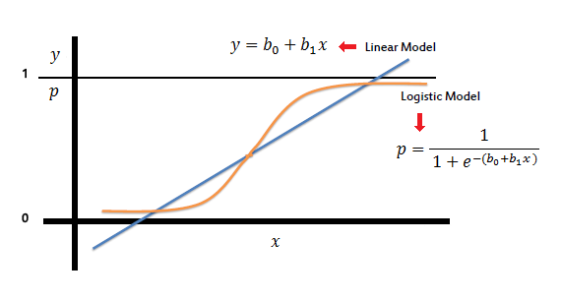
In the formula of the logistic model,
when b0+b1X == 0, then the p will be 0.5,
similarly,b0+b1X > 0, then the p will be going towards 1 and
b0+b1X < 0, then the p will be going towards 0.

Interpretation of the Coefficients
- Interpretation of the weights differ from the Linear Regression as the output of the Logistic Regression is in probabilities between 0 and 1.
- Instead of the slope co-efficient(b) being the rate of change of the p as x changes,now the slope co-efficient is interpreted as the rate of change of the “log odds” as X changes.
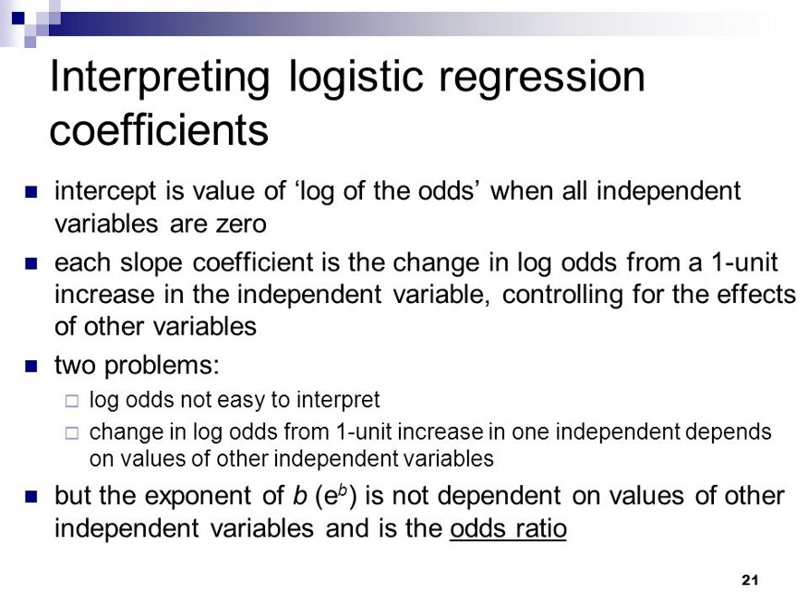

Odds Ratio and Logit
Odds ratio is defined as the ratio of the odds in presence of B and odds of A in the absence of B and vice versa.
In other words,Odds are the ratio of the probability of success to the probability of failure and Logit is Just the Log of the Odds Ratio.
Let’s understand this with example:
Assume the probability of success is 0.6.
So,probability of failure will be (1–0.6) = 0.4
Odds are determined from probabilities and range between 0 to ∞.
So,Now odds(Success) = p/(1-p) or p/q = 0.6/0.4 = 1.5
Also,odds(Failure) = 0.4/0.6 = 0.66667
Formula of Odds is:
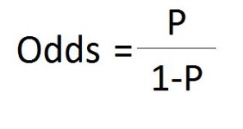
If we want the odds ratio between binary classes then:
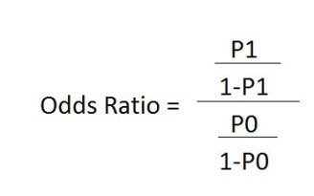
Logit Function is just the log of odds and the formula is :
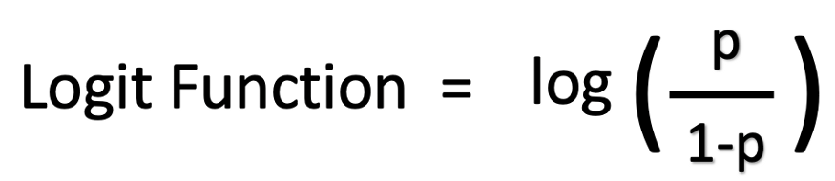
In Logistic regression we can calculate odds ratio between the classes:
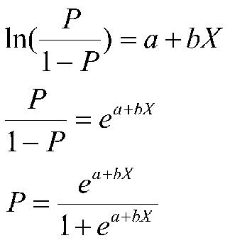
Now , that you’ve understood what odds ratio is let’s see what decision boundary is:

Decision Boundary
- A decision Boundary is a line or margin that separates the classes.
- Classification algorithm is all about finding the decision boundary that helps distinguish between the classes perfectly or close to perfect.
- Logistic Regression decides a proper fit to the decision boundary so that we will be able to predict which class a new data will correspond to.
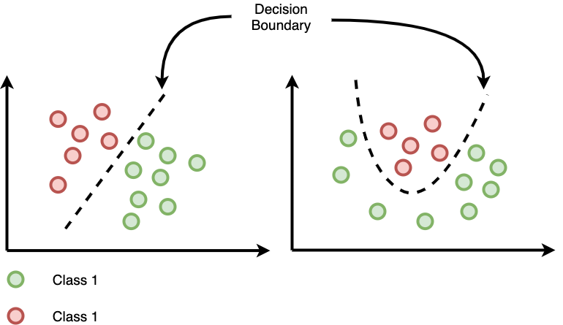
Now that you have understood what decision boundary is and how it is found.Let’s have the look of the cost function of the logistic Regression.

Cost Function of the Logistic Regression

Cost Function is a function that measures the performance of a Machine Learning model for given data.
Cost Function is basically the calculation of the error between predicted values and expected values and presents it in the form of a single real number.
Many people gets confused between Cost Function and Loss Function,
Well to put this in simple terms Cost Function is the average of error of n-sample in the data and Loss Function is the error for individual data points.In other words,Loss Function is for one training example,Cost Function is the for the entire training set.
So, when it’s clear what cost function is Let’s move on.
We know that the Logistic function is:
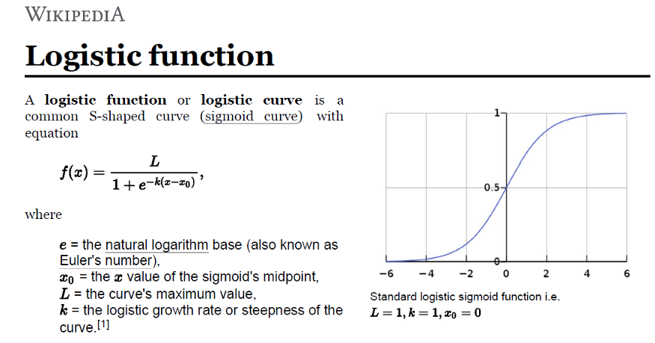
The main task for us is to find the best parameter(x) in the above equation present in the image to minimize the error.
Now, if you have seen the maths behind the decision boundary you will know that the parameter(x) is not limited to the logistic function it also contributes to the equation of the decision boundary.
It is very much similar to the Linear Regression,define a cost function to find the error and then perform gradient descent in order to update parameter and minimize the cost function.
But, we can not use the cost Function of Linear Regression Model.

Why we Can not use the Cost function of the Linear Regression?
Trying to use a cost function of the Linear Regression model using the Mean Squared Error will give a non-Convex function,which will give a weirdly shaped graph that looks like this.
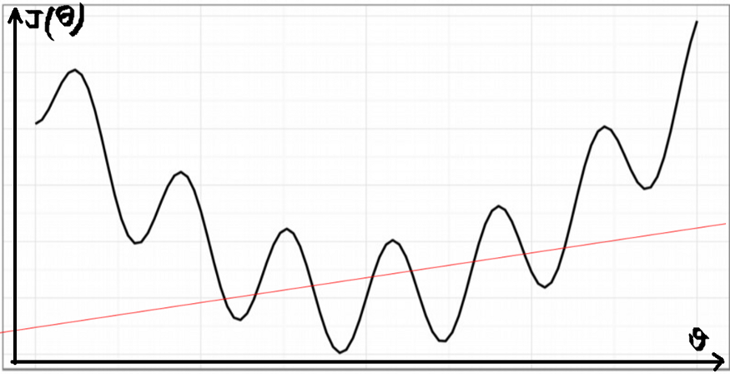
This graphs has many local minimums which makes it very hard for the cost function to reach global minimum and minimize the error.
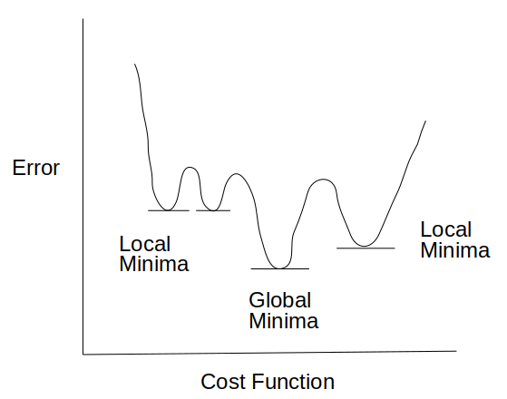
This happens because in Logistic Regression we have sigmoid function which is non-linear.
This is why Cost function for Logistic Regression is :

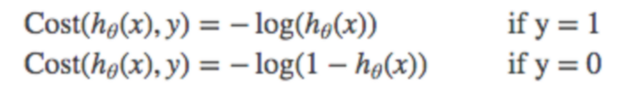
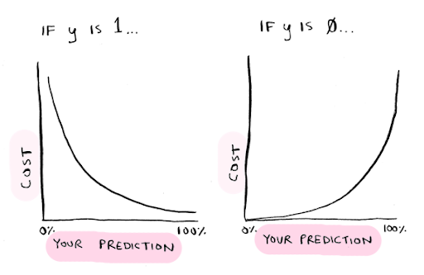
If you combine the above two equations in one,You will get a convex function and this cost function will help the Logistic Regression model converge towards Global Minimum faster.
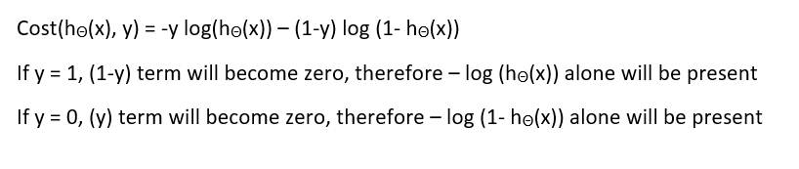
You Must be wondering why there is a negative(-) sign in the cost function,
Well if you see,the values present in the log will be probabilities between 0 and 1,So,The value of log1 is 0 and the value of log0 is negative(-) infinity.
So,the values from the cost function will always be in negative terms and that is why we add negative(-) sign to it.
Now that we know the cost function of the Logistic Regression let’s understand how do we minimize the error to get the high performing model
Gradient descent is an optimization algorithm used to find the values of parameters (coefficients) of a function that minimizes a cost function (cost).
Now,That you have the intuition about the gradient Descent,you can understand why we need to update the weights in order to reach the global minimum.
Steps followed by the Gradient Descent to obtain lower cost function:
Let’s have a look at the logistic(sigmoid) function.
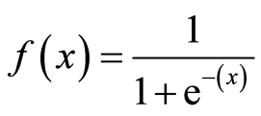
Here, x = mx+b or x = b0 + b1x
→ Initially,the values of m and b will be 0 and the learning rate(α) will be introduced to the function.
The value of learning rate(α) is taken very small,something between 0.01 or 0.0001.
The learning rate is a tuning parameter in an optimization algorithm that determines the step size at each iteration while moving toward a minimum of a cost function.
→ Then the partial derivative is calculate for the cost function is take.After Calculation the equation acheived will be.
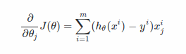
→ After the derivatives are calculated,weights are updated with the help of the following equation.
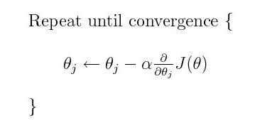
Which can also be written as:
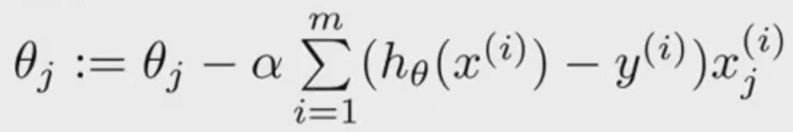
Why should we substract the weights(m and b)with the derivative?
Gradient gives us the direction of the steepest ascent of the loss function and the direction of steepest descent is opposite to the gradient and that is why we substract the gradient from the weights(m and b)
→ The process of updating the weights will continue until the cost function reaches the ideal value of 0 or close to 0.
After building the model it’s obvious for us to check how well our model is performing, how well it fits our data.
One of the approach to do this is by Measuring how well you can predict the dependent variable based on new set of independent variables.
- R2(R-Squared) value:
R-Squared calculated for Logistic Regression is not same as the R-Squared calculated for the Linear Regression Models.
These Pseudo R-Squared helps measure the predictive power of the model.
There are many different ways to calculate the R-Squared value for Logistic Regression,However,No one approach is agreed to be the best.But,among all the type of R-Squared value McFadden’s R-Squared is a better approach.
- AIC(Akaike Information Criteria):
* AIC is the estimator of the goodness-of-fit of the model.
* Whenever we create a model we loose some information,no one can create the perfect model. AIC estimates the amount of information loss.
* Lesser the value of AIC means Lesser the information lost which means better the model.
* Adding variables to the model will not increase the value of AIC.
* One of the use of AIC is also that it helps in selecting the model.We can fit the whole data to train the model and compare the AIC values of different models and select the model with the best AIC Value.
AIC = -2/N * LL + 2*K/N
Where,N is the number of samples in the training data,LL is the Log Likelihood of the model on the training data. and K is the number of parameters in the data.
- Other Methods Include Confusion Matrix,Roc-Auc Curve.
You Can Read About Confusion Matrix and Other metrics related to it in my blog Calculating Accuracy of an ML Model and Understanding the AUC-ROC Curve.

Logistic Regression
In this part of the exercise, you will build a logistic regression model to predict whether a student gets admitted into a university.
Problem context
Suppose that you are the administrator of a university department and you want to determine each applicant’s chance of admission based on their results on two exams. You have historical data from previous applicants that you can use as a training set for logistic regression. For each training example, you have the applicant’s scores on two exams and the admissions decision.
Your task is to build a classification model that estimates an applicant’s probability of admission based on the scores from those two exams.
First let’s load the necessary libraries.
import numpy as np
import pandas as pd
import matplotlib.pyplot as plt
import scipy.optimize as opt # more on this later

data = pd.read_csv('ex2data1.txt', header = None)
X = data.iloc[:,:-1]
y = data.iloc[:,2]
data.head()
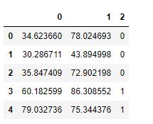
So we have two independent features and one dependent variable. Here 0 means candidate was unable to get an admission and 1 vice-versa.
Visualizing the data
Before starting to implement any learning algorithm, it is always good to visualize the data if possible.
mask = y == 1
adm = plt.scatter(X[mask][0].values, X[mask][1].values)
not_adm = plt.scatter(X[~mask][0].values, X[~mask][1].values)
plt.xlabel('Exam 1 score')
plt.ylabel('Exam 2 score')
plt.legend((adm, not_adm), ('Admitted', 'Not admitted'))
plt.show()
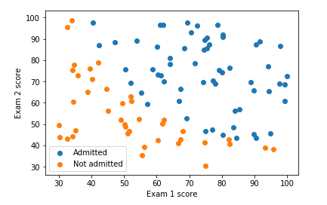
Implementation
Before you start with the actual cost function, recall that the logistic regression hypothesis makes use of sigmoid function. Let’s define our sigmoid function.
Sigmoid Function
def sigmoid(x):
return 1/(1+np.exp(-x))
Note that here we are writing the vectorized code. So it really doesn’t matter whether x is a scalar or a vector or a matrix or a tensor ;-). Of course writing and understanding the vectorized code takes some mind bending (which anyone will become good at after some practice). However, it gets rid of for loops and also makes for efficient and generalized code.
Cost Function
Let’s implement the cost function for the Logistic Regression.
def costFunction(theta, X, y):
J = (-1/m) * np.sum(np.multiply(y, np.log(sigmoid(X @ theta)))
+ np.multiply((1-y), np.log(1 - sigmoid(X @ theta))))
return J
Note that we have used the sigmoid function in the costFunction above.
There are multiple ways to code cost function. Whats more important is the underlying mathematical ideas and our ability to translate them into code.
Gradient Function
def gradient(theta, X, y):
return ((1/m) * X.T @ (sigmoid(X @ theta) - y))
Note that while this gradient looks identical to the linear regression gradient, the formula is actually different because linear and logistic regression have different definitions of hypothesis functions.
Let’s call these functions using the initial parameters.
(m, n) = X.shape
X = np.hstack((np.ones((m,1)), X))
y = y[:, np.newaxis]
theta = np.zeros((n+1,1)) # intializing theta with all zerosJ = costFunction(theta, X, y)
print(J)
This should give us a value of 0.693 for J.
Learning parameters using fmin_tnc
In the previous assignment, we found the optimal parameters of a linear regression model by implementing the gradient descent algorithm. We wrote a cost function and calculated its gradient, then took a gradient descent step accordingly. This time, instead of taking the gradient descent steps, we will use a built-in function fmin_tnc from scipy library.
fmin_tnc is an optimization solver that finds the minimum of an unconstrained function. For logistic regression, you want to optimize the cost function with the parameters theta.
Constraints in optimization often refer to constraints on the parameters. For example, constraints that bound the possible values theta can take (e.g., theta ≤ 1). Logistic regression does not have such constraints since theta is allowed to take any real value.
Concretely, you are going to use fmin_tnc to find the best or optimal parameters theta for the logistic regression cost function, given a fixed dataset (of X and y values). You will pass to fmin_tnc the following inputs:
- The initial values of the parameters we are trying to optimize.
- A function that, when given the training set and a particular theta, computes the logistic regression cost and gradient with respect to theta for the dataset (X, y).
temp = opt.fmin_tnc(func = costFunction,
x0 = theta.flatten(),fprime = gradient,
args = (X, y.flatten()))
#the output of above function is a tuple whose first element #contains the optimized values of theta
theta_optimized = temp[0]
print(theta_optimized)
Note on flatten() function: Unfortunately scipy’s fmin_tnc doesn’t work well with column or row vector. It expects the parameters to be in an array format. The flatten() function reduces a column or row vector into array format.
The above code should give [-25.16131862, 0.20623159, 0.20147149].
If you have completed the costFunction correctly, fmin_tnc will converge on the right optimization parameters and return the final values of theta. Notice that by using fmin_tnc, you did not have to write any loops yourself, or set a learning rate like you did for gradient descent. This is all done by fmin_tnc:-) You only needed to provide a function for calculating the cost and the gradient.
Lets use these optimized theta values to calculate the cost.
J = costFunction(theta_optimized[:,np.newaxis], X, y)
print(J)
You should see a value of 0.203 . Compare this with the cost 0.693 obtained using initial theta.
Plotting Decision Boundary (Optional)
This final theta value will then be used to plot the decision boundary on the training data, resulting in a figure similar to the one below.
plot_x = [np.min(X[:,1]-2), np.max(X[:,2]+2)]
plot_y = -1/theta_optimized[2]*(theta_optimized[0]
+ np.dot(theta_optimized[1],plot_x)) mask = y.flatten() == 1
adm = plt.scatter(X[mask][:,1], X[mask][:,2])
not_adm = plt.scatter(X[~mask][:,1], X[~mask][:,2])
decision_boun = plt.plot(plot_x, plot_y)
plt.xlabel('Exam 1 score')
plt.ylabel('Exam 2 score')
plt.legend((adm, not_adm), ('Admitted', 'Not admitted'))
plt.show()
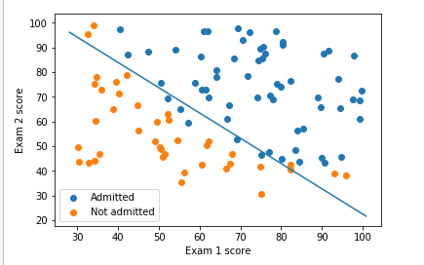
It looks like our model does a pretty good job at distinguishing the students who got the admission vs those who didn’t. Now lets quantify our model accuracy for which we will write a function rightly called accuracy
def accuracy(X, y, theta, cutoff):
pred = [sigmoid(np.dot(X, theta)) >= cutoff]
acc = np.mean(pred == y)
print(acc * 100)accuracy(X, y.flatten(), theta_optimized, 0.5)

